**Duty of Candour Policy:**

**Date effective: 02/02/24**

**Date review: 02/02/25**

**Version no: 1**

**Policy owner/author: Robyn Duffy**

Providing safe, effective and person-centred care is what Refine Beauty Aesthetics sets out to achieve with every client who seeks treatment. Building relationships with clients based on honesty, openness, kindness and overall good communication is paramount to providing an excellent service.

The Health (Tobacco, Nicotine etc. and Care) (Scotland) Act 2016 (The Act) and The Duty of Candour Procedure (Scotland) Regulations 2018 (The Regulations) set out a new Duty of Candour. The Act and the Regulations require organisations providing health services, care services and social work services in Scotland to follow a formalised procedure when there has been an unintended or unexpected incident that results in death or harm (or additional treatment is required to prevent injury that would result in death or harm). The purpose of this new duty is to ensure that providers are open, honest, supportive, and providing a person-centred approach.

The guidelines offer a set of processes that are either legally required or best practice should there be an incident resulting in harm or death. Refine Beauty Aesthetics wishes to provide high quality excellent care and being accountable for our actions and/or inactions is part of that. We wish for clients to feel safe, supported and have trust in our practitioner. As such Refine Beauty Aesthetics follows the guidelines to create its own duty of candour policy.

The need for candour:

As mentioned above, building relationships and trust with clients is part of providing excellent care. Healthcare practitioners have a responsibility for their actions and should an unintentional or unexpected harm or death happen, clients need to be supported with communication, personalised discussions and given supportive resources to ensure they feel safe and there is learning taken from the situation.

As Refine Beauty Aesthetics is run solely by Robyn, she has a responsibility to apologise if something goes wrong, have meetings to discuss about the incident, review what happened and learn from it. This also includes offering support or an appropriate remedy, if possible, to make matters right. Robyn will communicate with the client fully to explain what has happened, and what can be the short term or long-term effects of the incident.

Robyn is also registered with the Nursing and Midwifery Council (NMC) and British Association of Cosmetic Nurses (BACN) and as such is familiar with the duty of candour policy, and the requirements to report an incident if it leads to harm. This could include reporting to Healthcare Improvement Scotland, the Yellow Card scheme to inform the Medicines and Healthcare Products Regulatory Agency (MHRA) or the Health Facilities Scotland online incident reporting system.

As a sole worker, Robyn will conduct an audit using things like patient feedback to aid in preventing failure in her clinical performance and reduce the risk of incident. Robyn is familiar with HIS protocols and the yellow card scheme for reporting and knows how to report an adverse event should that happen. Making sure Robyn can learn from the experience, action is taken, and the subsequent practice is changed to prevent further injury or harm is good practice and promotes openness and honesty with clients.

Robyn will activate the duty of candour policy as soon as she is aware of an unintended or unexpected incident resulting in harm by her treatment of the client. This can be extended past one month, provided there is evidence that the treatment has caused death, permeant lessening of bodily, sensory, motor, physiologic or intellectual functions or the patient required further treatment in order to prevent death or injury.

Should an incident occur where it is directly relevant to the treatment provided by Robyn, she would seek review from another healthcare professional like the client’s own GP to decide whether the treatment was directly related to the harm or death. Should this not be possible, Robyn would contact HIS for further advice.

The below diagram helps assess whether the duty of candour must be activated if decided by an independent healthcare professional (not Robyn herself).

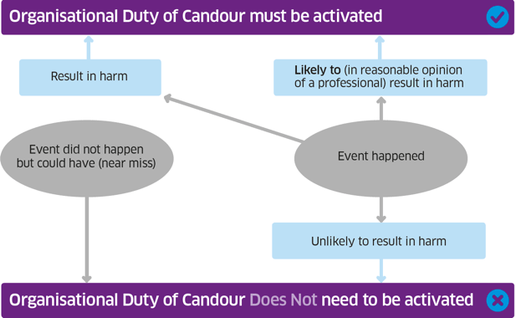

Should the duty of candour policy be implemented, it is good practice to inform clients within 10 working days of the procedure start date. Should it be a month or later after the initial treatment, Robyn will provide a reason as to why the duty of candour process has been initiated.

Robyn will either telephone or email a client to explain the duty of candour process. Should this not suit the client, or be an accessible option for the person, she will try to accommodate this and change the communication method. The client will also be offered an official apology in writing. If this is wished by the client, it will also detail the incident and provide facts relevant to the circumstances.

Robyn will detail why the process has started, including the facts of the incident she is aware of, and subsequent actions that will be taken and an explanation of the delay should it be one month or later since initial treatment.

Should a client consider or decide to make a claim, Refine Beauty Aesthetics will suggest that the client might want to wait until the duty of candour process is completed. Should the claim continue, duty of candour proceedings may have to be paused until the relevant legal process reaches a conclusion.

A meeting in person will be offered and the client will be given the opportunity to ask questions in advance. It will be a private, confidential meeting in the clinic and any relevant requirements for the client for the meeting will be attempted (eg. An advocate or an interpreter). The meeting will discuss the incident, any further investigations required that could help demonstrate what contributed or led to the failure, an opportunity for the client to ask further questions, an opportunity for the client to express their own views and thoughts and where the information regarding the incident will be relayed to if required including legal or regulatory procedures to be followed. Subsequently, the client will be given a note of the meeting and contact information for Robyn. Should the client not wish for a meeting or cannot attend, either another date will be set to suit the client, or information will be given to the client regarding the above.

Should further input be required from other organisations, Robyn will cooperate fully, and provide all the necessary information and facts regarding the incident. She will also demonstrate actions taken and the subsequent learning post incident. This ties into the review required, where Robyn will review the incident, learn from it, and potentially change clinic policy to improve client safety and the effectiveness of service. This will be completed within 3 months of the Duty of Candour being activated. The client affected will be sent a copy of this review as well.

Robyn will keep written records of any incidents in which the duty of candour was activated that include all relevant documentation.

Every year an annual report will be completed that will include information on the number and nature of the incidents where the duty was activated, and what policies or procedures were changed as a result. This will demonstrate learning from the incident. The report will be kept confidential, and not disclose any information including patient details that could identify the patient. If the report is published, it should be publicly accessible and copies sent to HIS, Scottish government ministers and the care inspectorate.

As part of improving the service given, Robyn will complete further training. This could be by completing modules on Turas or attending further training days.